Project Specification

for the

Construction Department of Southern Illinois University Edwardsville

by

Bryan Allen

Daniel Grote

Zach Smith

of

CS425 / CS499 Senior Project

Concrete Drying Application Team

CS-SPEC

Revision 1.0.8

As Of: 6 April 2015

**Change Log:**

|  |  |
| --- | --- |
| Revision | Change Note(s) |
| 1.0.4 | * Updated title under business and domain description * Added notifications to product functions * Added private data security under software system attributes |
| 1.0.5 | * Edit wording of pouring to placing along with other customer word changes |
| 1.0.6 | * Made changes to the following sections due to changes in requirements. 1.2, 3.3, 3.5, 4.3, 4.8. |
| 1.0.7 | * Updated Agile Use Cases |
| 1.0.8 | * Updated Agile Use cases |

**Reviewed and Approved By:**

|  |  |  |  |  |
| --- | --- | --- | --- | --- |
| Name | Signature |  |  | Date |
|  |  |  |  |  |
|  |  |  |  |  |
|  |  |  |  |  |
|  |  |  |  |  |
|  |  |  |  |  |

Table of Contents

1 INTRODUCTION 1

1.1 Business and Domain Description 1

1.2 Concept of Proposed System / Scope 1

1.2.1 Operational Concept and Scenario 1

1.3 Product Overview 2

1.3.1 Product Perspective 2

1.3.2 Product Functions 2

1.3.3 User Characteristics 2

1.3.4 Limitations 2

1.4 Definitions 3

1.5 Stakeholders 4

2 REFERENCES 4

3 SPECIFIC REQUIREMENTS 4

3.1 External Interfaces 4

3.2 Functions 5

3.2.1 Agile Use Cases 5

3.3 Usability Requirements 8

3.4 Performance Requirements 9

3.5 Logical Database Requirements 9

3.6 Design Constraints 10

3.7 Software System Attributes 10

3.8 Supporting Information 10

3.8.1 Sample input/output formats 10

3.8.2 Description of the problem to be solved by the software 11

4 VERIFICATION 11

4.1 External Interfaces 11

4.2 Functions 12

4.2.1 Agile Use Cases 12

4.3 Usability Requirements 12

4.4 Performance Requirements 12

4.5 Logical Database Requirements 12

4.6 Design Constraints 12

4.7 Software System Attributes 13

4.8 Supporting Information 13

5 APPENDICES 13

5.1 Assumptions and Dependencies 13

5.2 Acronyms and Abbreviations 13

**Figures**

Figure 1: Use Case Diagram 5

Figure 2: Evaporation Rate Example Output 11

**Tables**

Table 1: Stakeholders 4

# 1 INTRODUCTION

## 1.1 Business and Domain Description

The purpose of this document is to define the requirements of the Concrete Plastic Shrinkage Crack Risk Calculator Application and provide analysis. The business of placing concrete relies on the ability to determine whether or not shrinkage cracks will occur by calculating the evaporation rate. To calculate the evaporation rate, a nomograph is used in conjunction with weather data provided by the NOAA.

## 1.2 Concept of Proposed System / Scope

The software will forecast the probability of plastic shrinkage cracks in an easier and more efficient way. It will automatically pull weather data from the NOAA databases and calculate the evaporation rate every three/six hours from the current time up to the next 168 hours (1 week). Then the software will display this information in the form of a graph that the user will be able to zoom in and out of as well as textual data. In addition to displaying the information the software will allow users to enter desired dates, and the software will notify them via email, if the evaporation rates change for the selected days. One additional notification that will be supported will be notifying, again via email, users when selected days come into prediction range.

### 1.2.1 Operational Concept and Scenario

* The web site will be opened by visiting the URL. This may also be done by visiting the Construction Dept. of SIUE website, and clicking the appropriate link.
* Once the web page is open the user will be able to login with an account, create an account, or login as a guest.
* Once logged in the user will be on their home screen. On their home screen the user will be able to create, edit, delete, or view projects.
* When a project is created the user will be able to enter project specific data (such as location and name of the project).
* The user will be able to select a specific date and time to watch for evaporation rate changes and have a notification sent to them by email.
* The user will be able select a future date and time to notify the user when the selected date comes into prediction range.

## 1.3 Product Overview

### 1.3.1 Product Perspective

This project will rely on the NOAA site for weather data. When designing the user interface the idea is to make the interface simple and easy to use, but still displaying all the needed information. Keeping the different parts of the interface similar to each other is also a main goal.

1. system interfaces: access stored database of saved weather data, and user login database
2. hardware interfaces: N/A
3. software interfaces: NOAA database
4. communication interfaces: e-mail service
5. memory: 256 MB should be enough for the software to run
6. operations: pull data from NOAA, calculate evaporation rate, display calculated information

### 1.3.2 Product Functions

There will be four major functions this software must perform. The first will be pulling the required data off the NOAA site. The next is calculating the probability of shrinkage cracks. Next, the software will create an easy to read graph for the users. Lastly, the software will be able to notify the user if any changes occur in the predicted forecast.

### 1.3.3 User Characteristics

The targeted users will be construction managers that have access to Internet. The user should be familiar with how to navigate a website, and have experience reading graphs.

### 1.3.4 Limitations

* This software will not be able to update data used for calculations if Internet access is not available.
* The software can only retrieve updated weather data when the NOAA databases have been updated.
* The software can only retrieve updated weather data when the NOAA database is accessible at that time.

## 1.4 Definitions

**Concrete Curing** - waiting for the concrete to dry

**Concrete Floor Placement** - placing concrete to make a floor

**Concrete Project** - a specific concrete job site (multiple projects can exist)

**Concrete Shrinkage Cracks** - cosmetic and/or structural cracks that appear in concrete due to evaporation rate

**Contractors** - a person or company that undertakes a concrete floor placement

**Construction** - process of preparing and forming something

**Evaporation Rate** - rate at which water evaporates / used to forecast concrete plastic shrinkage crack probability in concrete floor placements

**Forecast** - predicting the evaporation rate

**Humidity** - amount of water vapor in the atmosphere (variable used to calculate evaporation rate

**Location** - the site where the concrete is going to be placed (zip code)

**Materials** - the substances that make up the concrete (variable used to calculate evaporation rate)

**National Oceanic and Atmospheric Administration (NOAA)** - the organization chosen to gather weather information from

**Nomograph** - chart used to manually predict the evaporation rate

**Notification** - an alert that brings a change to the user’s attention

**Percent Cloud Cover** - weather term to measure the amount of sunshine visible (variable used to calculate evaporation rate)

**Projects** - a specific job site (multiple projects can exist)

**Temperature** - measurement of how hot or cold and area is (variable used to calculate evaporation rate)

**User Interface** - what the user sees and interacts with

**Wind Direction** - the direction the wind is blowing (variable used to calculate evaporation rate)

**Wind Speed** - the speed at which the wind is blowing (variable used to calculate evaporation rate)

## 1.5 Stakeholders

Table 1: Stakeholders

|  |  |  |
| --- | --- | --- |
| **People / Group** | **Organization** | **Relationship** |
| Mark Grinter | SIUE Construction Dept. | Client |
| Anne Werner | SIUE Construction Dept. | Secondary Client |
| Software Users | N/A | User |

# 2 REFERENCES

Mayer, Gary “Semi-Agile Software Engineering (SAGE) Process Specification” Revision 2.1.3 18 August 2014: 1-40. Print

Mayer, Gary “Semi-Agile Software Engineering (SAGE) Deliverable Standard” Revision 1.0 06 September 2013: 1-12. Print

ISO/IEC/ IEEE “Systems and software engineering — Life Cycle Processes — Requirements Engineering” First Edition 1 December 2011: 1-83. Print

Uno, Paul “Plastic Shrinkage Cracking and Evaporation Formulas” ACI Materials Journal, 1998: 365-75. Print

# 3 SPECIFIC REQUIREMENTS

## 3.1 External Interfaces

N/A

## 3.2 Functions

### 3.2.1 Agile Use Cases

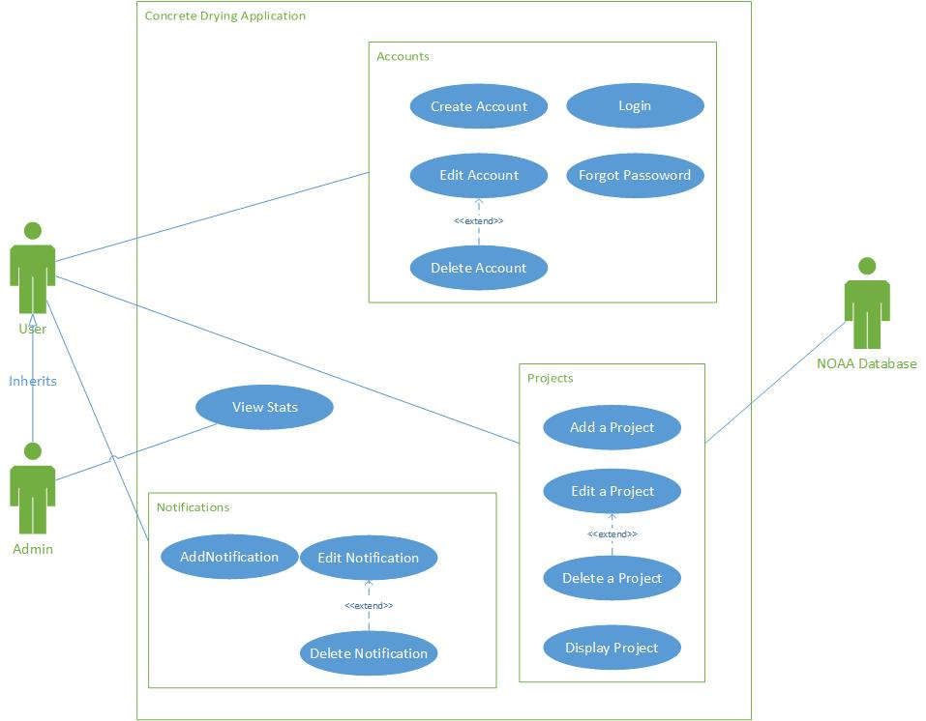

Figure 1: Use Case Diagram

**Create Account**

Trigger: User wants to create an account

1. User selects create account button.
2. User enters account specific data (ex. E-mail)
3. User submits form

**Forgot Password**

Trigger: The user forgot their password and wants a new one

1. User selects forgot password button
2. User enters their e-mail address
3. User submits form
4. Then user follows the instructions sent to them in the e-mail to change their password

**Login**

Trigger: User wants login to use software

1. User enters account information and submits.

**Edit Account**

Trigger: User wants to edit account information

1. User selects edit account button.
2. User changes the account specific data they wish to change
3. User submits form

**Delete Account**

Trigger: User wants to delete an account

1. User selects edit account button.
2. User selects delete account button

**View Stats**

Trigger: Admin wants to view website statics

1. Admin logs in
2. Admin selects view stats button
3. Stats are displayed

**Add Project**

Trigger: User wants to create a new project to forecast concrete plastic shrinkage. User logs in.

1. User selects add new project button
2. User enters project specific data (ex. location)
3. The Project name defaults to location
   1. User can choose to enter the project name
4. User submits form

**Edit Project**

Trigger: User wants to change the project name or project specific data

1. User selects the edit project Button
2. User selects the edit information button on the project that needs changed
3. User changes project specific data
4. User submits changes

**Delete Project**

Trigger: User wants to delete a project

1. User goes to project page
2. User selects the delete project button on the project that needs deleted

**Display Project**

Trigger: User wants to find the probability of concrete plastic shrinkage

1. User goes to project page
2. User selects ‘view’ on the project they want to view

**Add Notification**

Trigger: User wants to be notified if the probability of concrete plastic shrinkage dramatically changes on a user specified date

1. A logged in user views/or adds a project
2. User selects a point
3. User enters in notification date
4. User clicks submit

**Edit Notification**

Trigger: User wants to change a notification

1. User selects the project with the notification that needs changed
2. User selects the edit notifications button
3. User selects the edit button on the notification that needs to be changed
4. User changes the notifications date or parameters.
5. User submits changes

**Delete Notification**

Trigger: User wants to delete a notification

1. User selects the project with the notification that needs to be deleted
2. User selects the edit notification button
3. User selects the delete button on the notification that needs to be deleted

**Add a series concrete temperature/ wind speed**

Trigger: User wants change a concrete temp/ wind speed for a point.

1. User displays graph
2. User enters in a new concrete temperature
3. User selects inside or outside wind speed
4. User clicks submit

**View suggested concrete temperature for moderate/low risk**

Trigger: User wants to see what the concrete temperature needs to be to be in the moderate/low risk.

1. User displays graph
2. User hovers over a point
   1. If point is in high risk
      1. Display concrete temperature needed for moderate risk
      2. Display concrete temperature needed for low risk
   2. If point is in moderate risk
      1. Display concrete temperature needed for low risk

## 3.3 Usability Requirements

* The site should be quick and easy to learn.
* The site should be easy to navigate.
* The site output (graph) should be clear and understandable.
* The user should trust the site output.

## 3.4 Performance Requirements

* 95% of data retrieval shall take place in less than five seconds
* Formula calculation shall take less than 1 second to complete

## 3.5 Logical Database Requirements

User Table:

* User
  + First name
  + Last name
  + User name
  + UserID
  + Password
  + E-mail
  + Current number of notifications

Projects Table:

* Project
  + userID
  + projectID
  + zip code
  + Date created

Weather Date Table

* Weather Data
  + projectID
  + time
  + EvapRate
  + Air temp
  + Concrete temp
  + Relative humidity
  + Wind speed
  + Percent Cloud cover
  + Type of risk (high/med/low)

Future Notification Table

* Future Notification
  + ProjectID
  + FutureNotificationID
  + FutureDate

Change in State Notification Table

* Change in State Notification
  + UserID
  + ProjectID
  + ChangeInStateNotifcaitonID
  + startTime
  + endTime
  + needed evaporation rate (if the evaporation rate is below/above this user specified number during a start time or end time email the user)

Web site statistics Table

* Usage Statistics
  + Number of users
  + Number of projects
  + Number of times guest was used
  + Number Of Future Notifications
  + Number of Change in State notifications used
  + Etc.

## 3.6 Design Constraints

* User must have Internet access to use the software.
* The NOAA database must be up and available or the project information will not be accurate and the notifications will not be sent.

## 3.7 Software System Attributes

* Reliability – The software must work all the time when there is Internet connection and the NOAA database tables are live. If the NOAA database tables are currently unavailable the software will notify the user.
* Availability – Software should be readily available when the user has access to the Internet.
* Security
  + Check data integrity for critical variables
  + Validate data entry
  + Encrypting private data
* Maintainability – Software modules should be loosely coupled so that new requirements can be easily added.
* Portability – Software must run on anything that can host web sites.
* Robustness – If connection with the NOAA database is lost or unreliable, data from the last access to NOAA will be used instead of current data.

## 3.8 Supporting Information

### 3.8.1 Sample input/output formats

Input would be textboxes where user enters into textboxes.

The output would be a color-coded line graph. Green would mean it is safe to place. Yellow would be caution (Take caution when placing). Yellow would also give tips/steps on how to reduce the chance of concrete plastic shrinkage. Red would mean do not place.

These items should be considered part of the requirements.

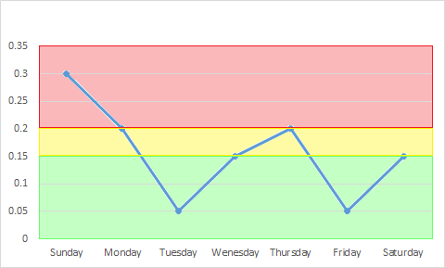

Figure 2: Evaporation Rate Example Output

### 3.8.2 Description of the problem to be solved by the software

The software would automate the process of calculating the evaporation rate for a given location and time, then display the information in an easy to read format.

# 4 VERIFICATION

The client verifies this document to ensure that the proposed requirements are the desired requirement.

## 4.1 External Interfaces

N/A

## 4.2 Functions

### 4.2.1 Agile Use Cases

Each use case must be represented and each use case needs to contain the necessary functionality of the application. The use cases need to be verified to see whether or not the needed functionality is present.

## 4.3 Usability Requirements

* Provide different prototypes for possible graphs for the client to choose.
* Show the weather variables and calculations that were used so the user can check the calcuations.
* Provide an about page to explain the calcuations used and where the weather predictions are coming from.
* As little data entry as possible to simplify things
* Do the calculations manually and compare the results to the results of the applications formula.

## 4.4 Performance Requirements

* Run the data retrieval at varying times throughout the day on multiple days, and during different network conditions.
* Run the formula calculation with various data multiple times.

## 4.5 Logical Database Requirements

Perform testing to determine if the proper projects and notification are in the database and are correctly displayed.

## 4.6 Design Constraints

Perform testing to verify the application notifies the user when there is no Internet access and/or there is not up to date data being used in the application.

## 4.7 Software System Attributes

* Reliability – See section 4.4
* Availability – Connect to the website throughout a day to make sure it is connecting.
* Security
  + Test to see if weather variables have changed since last use.
  + Test variable validation
  + Verify that personal information is encrypted
* Maintainability – Perform preventive maintenance to reduce future maintenance cost.
* Portability – Install on multiple operating systems to verify.
* Robustness – Test to see if data from the last access to NOAA is used.

## 4.8 Supporting Information

Provide different prototypes of different input and ouput methods for the client to choose and create as little data entry for users as possible.

# 5 APPENDICES

## 5.1 Assumptions and Dependencies

* Users will have Internet access
* Users will use one of the three Internet browsers: Google Chrome, Microsoft Internet Explorer, or Mozilla Firefox
* NOAA database is live and has the forecast predictions
* If user wants notifications they must use an account

## 5.2 Acronyms and Abbreviations

**NOAA** - National Oceanic and Atmospheric Administration